COLDTRACK
Dairy Inventory Risk Analysis
SQL Analysis Report

Prepared by · Yash Kumar
BigQuery SQL
Dataset: 4,325 records · 11 Brands · 2019 – 2022

Project Overview

This document presents SQL queries written in BigQuery to investigate the cold-chain inventory risk found in the ColdTrack dairy supply chain dataset. Each query builds on the previous — forming a narrative from delivery failure identification through to root cause and stock behaviour.
The queries directly informed the insights built into the ColdTrack Power BI dashboard, including the identification of ₹141K in preventable cold-chain losses.
ANALYSIS STRUCTURE

1–2 Delivery & Transport Failure — Identify which products require multiple restock cycles
3–4 Storage Type Risk — Expiry rate breakdown by storage condition
5 Root Cause Test — Prove or disprove reorder quantity as the cause
6 Stock Behaviour — On-time deliveries — stock vs minimum threshold
7 Timing Breakdown — Production-to-sale gap vs shelf life
8–9 Product & Seasonal Patterns — Per-product stock levels and monthly demand

QUERY 01
Identifying Products Needing Multiple Restock Trips

WHY THIS QUERY

The dashboard showed 32 cases where restocking needed 3+ transport cycles. This query calculates exactly how many trips each product required — exposing which products are most operationally expensive to restock.
SQL

SELECT *,
CASE
WHEN `Quantity_in_Stock_liters&kg`
<= `Minimum_Stock_Threshold_liters&kg`
AND `Quantity_in_Stock_liters&kg`
+ (`Reorder_Quantity_liters&kg`
* CEIL((`Minimum_Stock_Threshold_liters&kg`
- `Quantity_in_Stock_liters&kg`)
/ `Reorder_Quantity_liters&kg`))
> `Minimum_Stock_Threshold_liters&kg`
THEN CEIL((`Minimum_Stock_Threshold_liters&kg`
- `Quantity_in_Stock_liters&kg`)
/ `Reorder_Quantity_liters&kg`)
ELSE 0
END AS transport_cycles_needed
FROM `supplychain.dairy`

QUERY RESULT

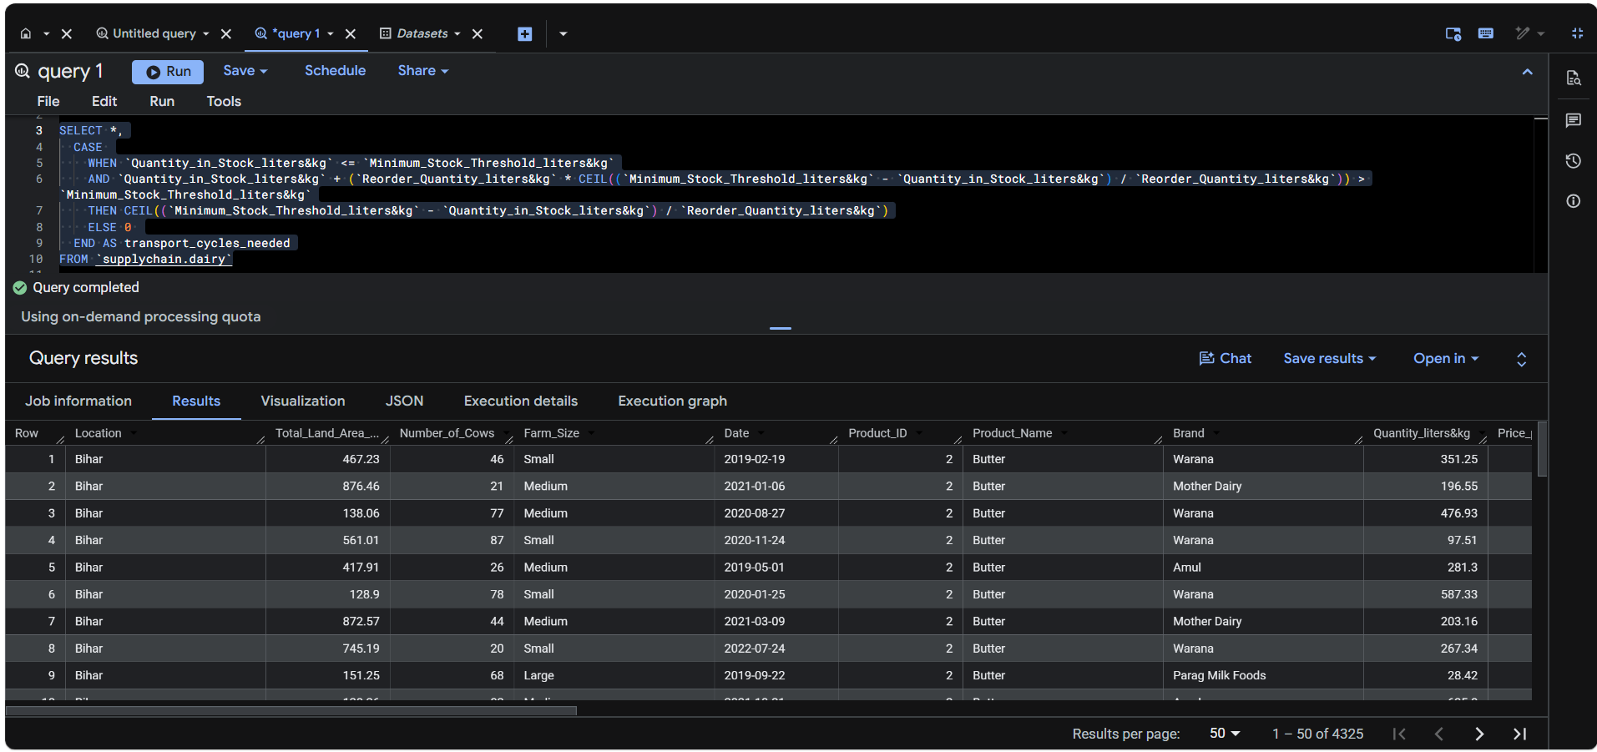
KEY INSIGHT

Products falling below minimum threshold trigger multiple restock cycles. Each additional cycle adds cold-chain cost and increases expiry exposure window.

QUERY 02
Which Products Need 2+ Transport Cycles Most Often?

WHY THIS QUERY

Extends Query 01 using a CTE to rank products by frequency of 2+ cycle restocking events. This identifies the highest operational cost products from a logistics perspective.
SQL

WITH cycle AS (
SELECT *,
CASE
WHEN `Quantity_in_Stock_liters&kg`
<= `Minimum_Stock_Threshold_liters&kg`
THEN CEIL((`Minimum_Stock_Threshold_liters&kg`
- `Quantity_in_Stock_liters&kg`)
/ `Reorder_Quantity_liters&kg`)
ELSE 0
END AS transport_cycles_needed
FROM `supplychain.dairy`
)
SELECT Product_Name,
COUNT(*) AS transport_count
FROM cycle
WHERE transport_cycles_needed >= 2
GROUP BY 1
ORDER BY 2 DESC

QUERY RESULT

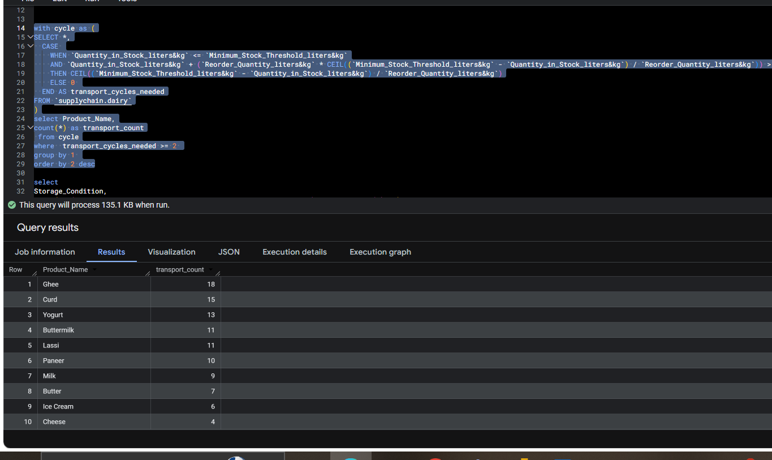
KEY INSIGHT

Ghee (18), Curd (15), and Yogurt (13) are the most transport-intensive products. These three should be prioritised in any reorder planning optimisation.

QUERY 03
Expiry Rate by Storage Type

WHY THIS QUERY

The dashboard showed Refrigerated storage with the highest absolute failure count (715). But volume can be misleading. This query calculates the percentage of deliveries that expired within each storage type — a more honest measure of failure rate.
SQL

SELECT Storage_Condition,
ROUND(
SUM(CASE WHEN Deliver_expire_product IS TRUE
THEN 1 ELSE 0 END) * 100 / COUNT(*),
2) AS expiry_delivery
FROM `supplychain.dairy`
GROUP BY 1

QUERY RESULT

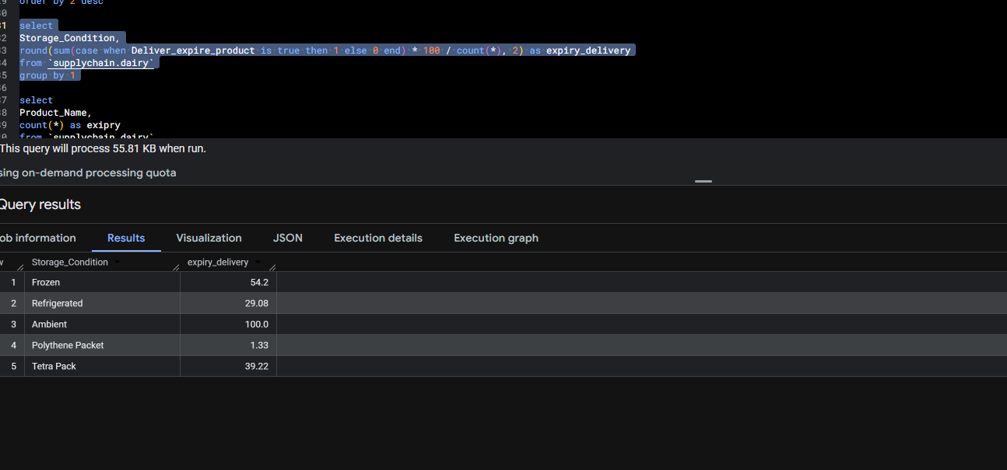
KEY INSIGHT

Frozen storage has a 54.2% expiry rate — the genuine high-risk category. Refrigerated's high absolute count (715) is driven by volume, not failure rate.

Note: Ambient storage shows 100% expiry rate, but this is because Ambient only stores Ghee — a product with very long shelf life. These are not true expiry failures but a data segmentation artefact.

QUERY 04
Frozen Storage — Which Products Expired Most?

WHY THIS QUERY

Frozen storage has a 54.2% expiry rate. This query drills into Frozen specifically to identify which products are driving that failure — enabling targeted corrective action.
SQL

SELECT Product_Name,
COUNT(*) AS expiry
FROM `supplychain.dairy`
WHERE Storage_Condition = 'Frozen'
AND Deliver_expire_product IS TRUE
GROUP BY 1
ORDER BY 2 DESC

QUERY RESULT

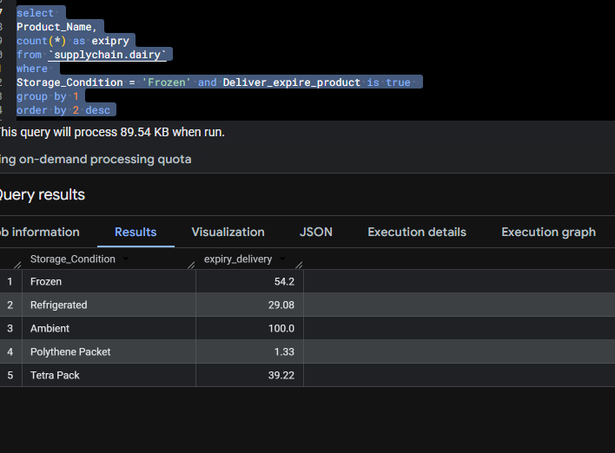
KEY INSIGHT

Cross-validates Query 03 at product level within frozen storage. The expiry concentration within Frozen confirms it as the priority storage type for cold-chain intervention.

QUERY 05
Reorder Quantity — Expired vs On-Time Deliveries

WHY THIS QUERY

A natural hypothesis: were expired deliveries ordered in larger quantities, causing stock to sit longer and expire? This query directly tests that hypothesis by comparing average reorder quantities between expired and on-time deliveries.
SQL

SELECT
ROUND(AVG(CASE
WHEN Deliver_expire_product IS TRUE
THEN `Reorder_Quantity_liters&kg`
END), 2) AS avg_reorder_expiry_delivery,
ROUND(AVG(CASE
WHEN Deliver_expire_product IS FALSE
THEN `Reorder_Quantity_liters&kg`
END), 2) AS avg_reorder_ontime_delivery
FROM `supplychain.dairy`

QUERY RESULT

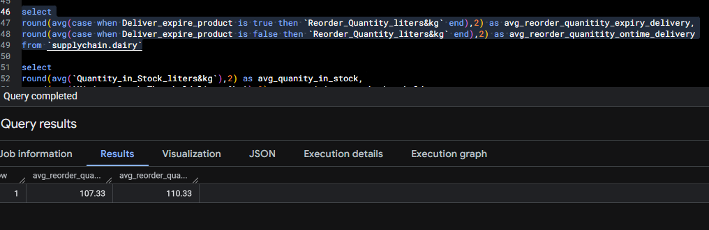
KEY INSIGHT

Expired (107.33) vs On-time (110.33) — virtually identical. Reorder quantity is definitively NOT the root cause of expiry. The problem lies in delivery timing and storage management.

QUERY 06
Stock Level vs Minimum Threshold (On-Time Deliveries)

WHY THIS QUERY

Having ruled out reorder quantity, we examine stock behaviour in deliveries that arrived on time. How much stock was being held relative to the minimum required threshold?
SQL

SELECT
ROUND(AVG(`Quantity_in_Stock_liters&kg`), 2)
AS avg_quantity_in_stock,
ROUND(AVG(`Minimum_Stock_Threshold_liters&kg`), 2)
AS avg_minimum_stock_threshold
FROM `supplychain.dairy`
WHERE Deliver_expire_product IS FALSE

QUERY RESULT

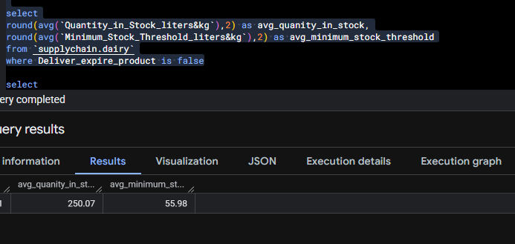
KEY INSIGHT

On-time deliveries held avg stock of 250.07 against a minimum threshold of only 55.98 — overstocked by 4.5x. Holding excess cold stock for extended periods directly drives expiry risk.

QUERY 07
Avg Production-to-Sale Gap vs Avg Shelf Life

WHY THIS QUERY

The most structurally important query. It compares how long products take to move from production to the customer against their actual shelf life — revealing whether the supply chain is fast enough for the products it handles.
SQL

SELECT
ROUND(AVG(DATE_DIFF(Date,
Production_Date, DAY)), 0) AS avg_gap,
ROUND(AVG(Shelf_Life_days), 0) AS avg_shelf_life
FROM `supplychain.dairy`

QUERY RESULT

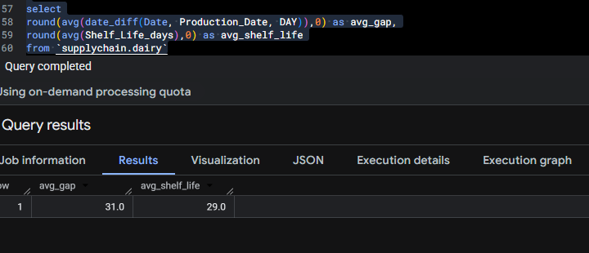
KEY INSIGHT

Avg gap from production to sale = 31 days. Avg shelf life = 29 days. The supply chain takes longer to deliver products than the products can survive. This is the structural root cause of expiry.

QUERY 08
Stock Levels by Product

WHY THIS QUERY

Validates the universal overstocking pattern observed in the dashboard (2K overstock count). Breaks down average stock, minimum threshold, and reorder quantity per product — showing which products are most chronically overstocked.
SQL

SELECT Product_Name,
ROUND(AVG(`Quantity_in_Stock_liters&kg`), 0)
AS avg_stock,
ROUND(AVG(`Minimum_Stock_Threshold_liters&kg`), 0)
AS avg_min_stock,
ROUND(AVG(`Reorder_Quantity_liters&kg`), 0)
AS avg_reorder_stock
FROM `supplychain.dairy`
GROUP BY 1
ORDER BY 2 DESC

QUERY RESULT

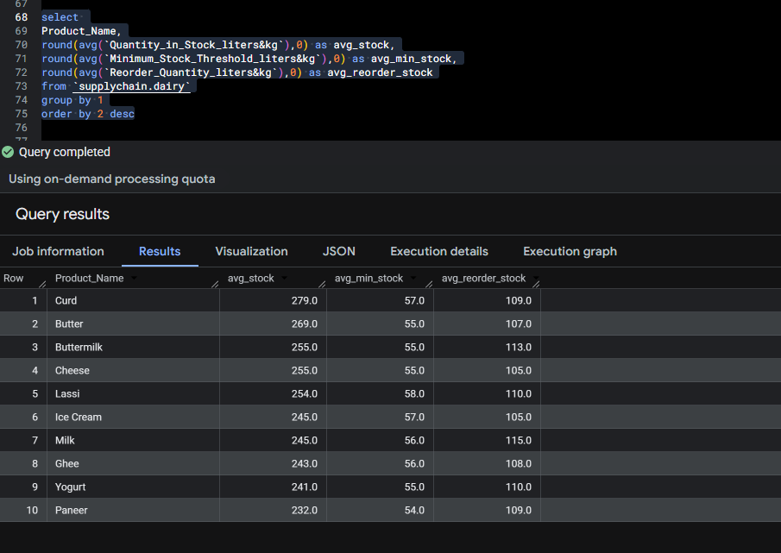
KEY INSIGHT

Every product holds stock 4–5x above its minimum threshold. Curd leads at 279 vs threshold of 57. This universal pattern confirms fixed-quantity reorder cycles — entirely disconnected from actual demand.

QUERY 09
Monthly Sales Volume

WHY THIS QUERY

Demand seasonality is a prerequisite for building the demand-based reorder strategy recommended in the Optimization Strategy page. This query identifies which months drive peak and trough demand.
SQL

SELECT EXTRACT(MONTH FROM date) AS month,
SUM(`Quantity_Sold_liters&kg`) AS quantity_sold
FROM `supplychain.dairy`
GROUP BY 1
ORDER BY 2 DESC

QUERY RESULT

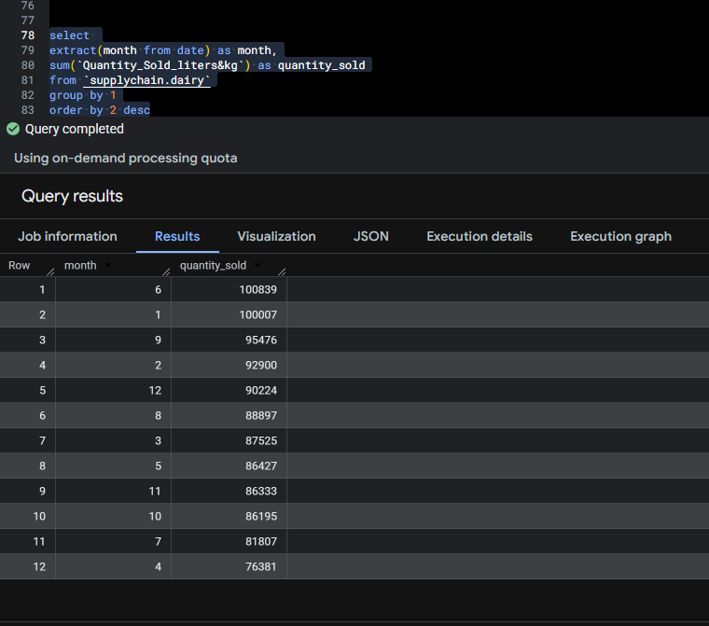
KEY INSIGHT

June (month 6) and January (month 1) are peak demand months. April is the lowest. Safety stock should increase 20–30% entering peak months — directly supporting the Optimization Strategy recommendation.

Key Findings Summary

01 Structural Timing Failure
Avg production-to-sale gap (31 days) exceeds avg shelf life (29 days) — the supply chain is too slow for the products it handles.

02 Ambient Storage — Not a True Risk
100% expiry rate in ambient storage is misleading. Ambient only stores Ghee, which has a very long shelf life. This category is not a concern.

03 Frozen Storage — Critical
54.2% of frozen deliveries expired. Frozen storage is the real high-risk category requiring immediate cold-chain intervention.

04 Reorder Quantity Is NOT the Cause
Expired (107.33) vs on-time (110.33) deliveries have near-identical reorder quantities — quantity is not driving expiry.

05 Universal Overstocking
Every product holds avg stock 4–5x above minimum threshold. Fixed reorder cycles — not demand — are driving this.

06 Peak Demand Months
June and January are highest sales months. Safety stock should increase 20–30% during these periods.

07 Highest Logistics Cost Products
Ghee (18), Curd (15), and Yogurt (13) require most multi-trip restocking. These three need priority reorder planning.

08 Preventable Loss
₹141K over 4 years (~₹35K/year) is attributable to cold-chain delivery delays — preventable with demand-based reordering.

Yash Kumar · BigQuery SQL · ColdTrack Project · 2026

